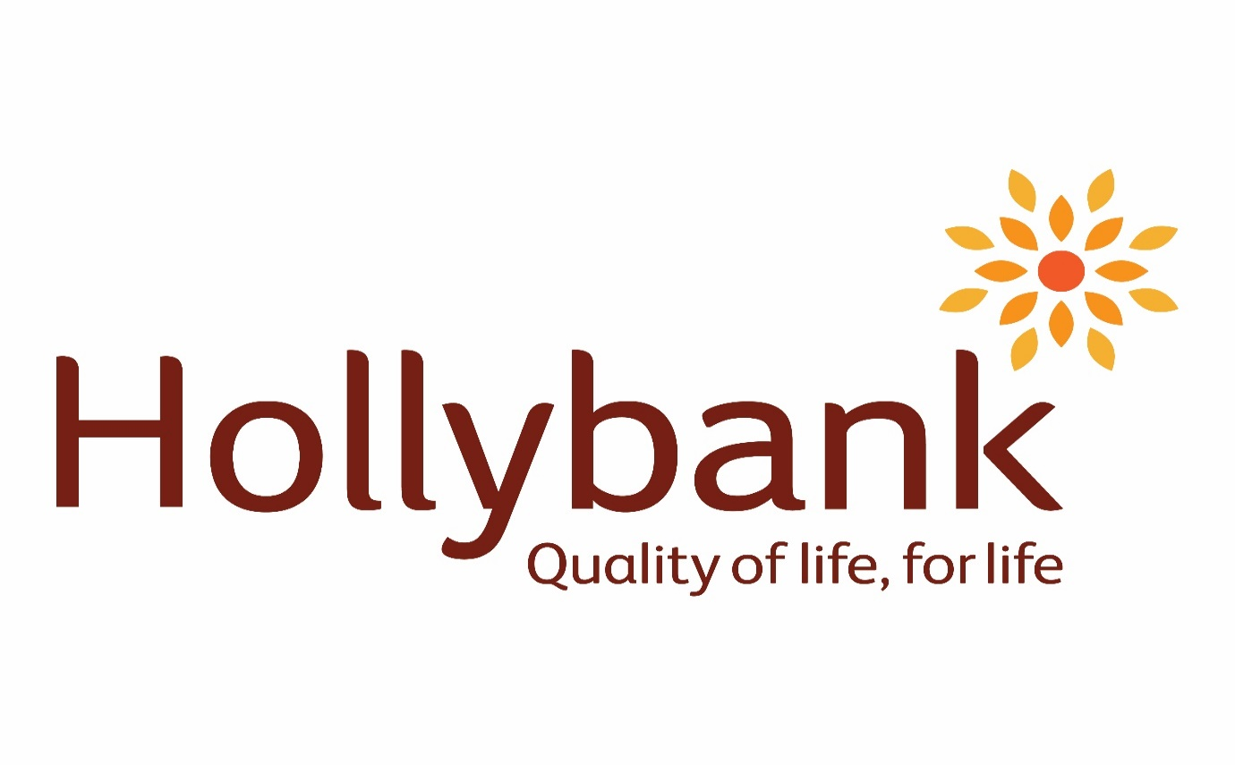

Communication and Literacy policy

Policy ID: | POLCLPGOV
Version: | 2.0
Review Date | 3rd February 2026
Next Review Date | 3rd February 2029
Policy Owner: | Headteacher

Version History
Version Number | Date | Editor | Changes
1.0 | 20/03/23 |  | New policy to be reviewed every three years unless DFE advise changes.
2.0 | 03/02/26 |  | 3 Yearly Review – Date changes.
Introduction
As a precursor to learning abstract, formal symbolic communication (letters/words) the pupil needs to be motivated to communicate. At Hollybank we acknowledge that children are exposed to literacy from birth, without the expectation of a response or active engagement from the child. Therefore, we respect the need to provide our learners with an environment rich in opportunities to proactively engage in communication and early literacy activities. On a daily basis, learners at Hollybank school benefit from quality interactions with familiar, trained staff and receive good quality input; constantly. Examples of ‘good quality input’ include modelled AAC, shared reading, rhymes and rhythms and experimentation with oral sounds (including letter sounds).
It is crucial that any approach to encouraging communication and emergent literacy is underpinned by assumed competence since this drives high expectations and facilitates meaningful achievements.
See below for a visual provided by practicalaac.org
- Perception drives EXPECTATION
- Expectation drives OPPORTUNITY
- Opportunity drives ACHIEVEMENT
- Achievement drives PERCEPTION
The visual demonstrates how the staff members perception of what a learner is capable of drives their expectations and therefore the opportunities that they will provide the learner with. Providing the child with frequent and regular opportunities to learn about communication and emergent literacy will increase their achievements and progress – they will learn more. Once the child is seen to make progress in areas in which they learn, the staff member’s perception of the child’s competence will also progress, and a positive cycle of learning and progress will take place. This model equally applies to negative perceptions of children which produce reduced expectations, limited opportunities to learn, and failure to progress. The model emphasises the importance of assuming competence from the start of (and throughout) the child’s education and beyond.
Every approach mentioned below is reliant on the child’s individual access methods for example, considering sensory and physical needs and stage of development. The approaches must be based in the child’s interests and motivators and be repeated across a range of interesting and fun contexts. Staff must work to discover what the child’s motivators are and then use this as the basis for developing communication and literacy skills.
 | Communication | Literacy – developed in line with communication
All of our pupils will experience (on a daily basis): | Attention and listening activities.  Constant exposure to core vocabulary (more, stop, yes, no, go etc.)  Modelling of an appropriate communication system, that challenges expectations. (All language is reinforced with physical action e.g. Makaton, TaSSels or a visual cue e.g. symbols)  Access to a communication system at an appropriate and suitable level.  Early interaction development e.g. intensive interaction, positive touch.  An environment that is responsive to their communication methods i.e. a Total Communication environment.  Having a communication passport.  Specially trained staff in communication methods.  The chance to make mistakes whilst communicating.  Cause and effect activities using technology e.g. switch, eye gaze, touchscreens. | Early conceptual development through play.  Shared reading in an engaging and meaningful way.  A language rich environment (increased visual and auditory exposure to print and words)
Most of our pupils will experience: | All of the above  A bespoke, multimodal communication system.  The chance to express a need, want or choice using their formal communication method.  The chance to simulate ‘babbling’ on a communication system.  Recognition of core vocabulary (more, stop, yes, no, go etc.)  Exposure to fringe vocabulary. | All of the above  Access to alternative pencils.  Exposure to the alphabet on a regular basis (signed, braille, print).  Auditory and sight recognition of their name.  Exposure to the initial sounds in words e.g. hearing the sound separated from the word or looking at the initial sound in words.
Some of our pupils will experience: | All of the above  Use of a robust communication system (used in all environments).  Use of fringe vocabulary. | All of the above  Spell and/or write their name  Segmenting and blending of some simple CVC or CVCC words.  Identifying the initial sounds in words.  Functional use of alternative pencils.  Sight recognition of familiar words.

Modelled AAC/Modelled Language- All communication partners surrounding the child must use the communication method that the child uses, or is aiming to use. A child must be surrounded by examples of their own communication method being used, in the same way that a baby who is learning to talk is surrounded by speech from birth. With no expectation that they will immediately repeat a word. This shows that we value that method of communication, speech is not the ‘gold standard’, and we can all learn this new method together.
Core Vocabulary- A set of words, signs or symbols (Hollybank Core boards start at 9 symbols and increase to books of 50+) that are applicable across a range of settings. These are usually not ‘topic specific’ but can become so, based on individual’s needs.
Shared Reading- Interactive reading where children join in with the activity (reading with the child not to the child). The child is guided to explore the words, concepts, pictures, symbols, sensory objects involved.
Multimodal Communication System- A method of communication that uses a variety of methods. There may be 1 or 2 formal systems (such as speech or symbols), but these are used within the contexts of additional methods, such as facial expression, body language, gesture, environmental cues.
Alternative Pencils- A way to access the full alphabet, for students with physical, sensory or learning difficulties who may struggle to use an ordinary pencil. Students should have access to this no matter what level of understanding they appear to have about print, from exploration to emergent writers, to conventional writers.
Developed by Hanser (2009) at the Centre for Literacy and Disability Studies (CLDS), an alternative pencil is defined as anything that provides a student with access to all 26 letters of the alphabet
See: https://literacyforallinstruction.ca
Written by Sally Barowik and Jenny Pemberton

