

Complaints & Concerns

Policy ID: | POLCACQC
Version: | 9.3
Review Date | 28th July 2026
Next Review Date | 28th July 2027
Policy Owner: | Head of Quality
Version History

Version Number | Date | Editor | Changes
2.0 | 8/11/18 | Wendy Porter | Changes to the complaint structure, removal of the Deputy Manager roles within the procedure. Addition of a flow chart to clarify the process. Added references to KLOE and Duty of Candour.  Addition to the introduction and the Advocacy information.  Additional bullet points to the procedure introduction.  Letter templates added.
3.0 | 22/08/19 | Wendy Porter | Updated policy with all Trustee Director and Head of Residential comments
4.0 | 10/9/19 | Wendy Porter | Updated policy with Trustee Director and Executive Team comments
5.0 | 30/9/19 | Richard Baines | Formatting Fixed to reflect recommendations from all Trustee Director Comments from September 2019
6.0 | 01/09/20 | Wendy Porter | Additions made to the policy include addition of section 8 and 10. Further information added to section 9 about external body signposting and how we will work with external bodies should a complaint come through.
7.0 | 26/07/21 | Anna O’Mahony | Reviewed with Quality Committee, addition to complaint flow chart.
8.0 | 26/07/22 | Anna O’Mahony | Annual review. Job title changes
9.0 | 13/07/23 | Anna O’Mahony | Annual Review.  Section 2. changes to department name  Section 3. Changes to Advocacy organisation detail. Section 11. Changes to Annual Reporting
9.1 | 22/07/2024 | Helen Whittaker | Paragraphs numbered.  6.1 Care Quality Commission changed to Health and Social Care Act 2008 (Regulated Activities) Regulations 2014  Key Lines of Enquiry changed to Key Outcome Areas  Flow chart changed to extend timescale to receive appeal from 5 working days to 20 working days
9.2 | 02/07/2025 | Helen Whittaker | No changes.
9.3 | 28.07.2026 | Helen Whittaker | No changes.

Contents

Contents 3
1. Introduction 5
2. Complaints from Families, Carers, Significant People, External Stakeholders, Staff and Visitors 5
3. Complaints from Children, Young People and Adults 6
4. Complaints from family members or personal acquaintances of a Child, Young Person or Adult 6
5. Non Residential Service Complaints 6
6. Procedure 7
7. Time Scales 8
8. Withdrawing a Complaint 9
9. Next Steps 11
10. One Complaint One Response 11
11. Annual Reporting 11
12. Letter Templates 12
13. Related Policies 12
Appendix Letter Templates 13
Acknowledgement of Complaint Template 13
Confirmation of Investigator and Process template 14
Complaint Outcome Letter Template 15
Acknowledgment of Appeal Template 17
Appeal outcome Letter Template 18
Appendix Example Letters for Children, Young People and Adults 20
Complaint 20
Compliment 38

Introduction
1.1 All our services and departments rely and depend on feedback from children, young people and adults, primary carers or other significant 'users' of the service offered. By listening to the people we care for, we will improve our services and continue to make them safer and more responsive. The feedback we receive will benefit everyone, not only those who receive our service but the families, commissioners, our staff and all of our other stakeholders.

1.2 This policy is to give guidance on how to raise a concern, make a complaint and how this will be processed and is for our adults, families, carers, significant people, external stakeholders and anyone accessing our services across Hollybank Trust.

What you can expect:
You will be treated fairly
You will be listened to
You will be dealt with in an open and transparent way

The service you or others receive will not be adversely affected

Complaints from Families, Carers, Significant People, External Stakeholders, Staff and Visitors
2.1 Children, young people and adults and their primary carers potentially deal with all members of staff within residential services at some time or another. However, Senior Support Workers, as part of their role, have responsibility for overseeing/reviewing individual children, young people and adults support plans. It is hoped that these children, young people and adults and primary carers will develop such relationships with their 'named' worker that any concerns will be discussed at an early stage and be resolved. If a child, young person or adult wants to make a complaint they can do this with support from our Speech and Language Team who will work with all relevant people and use specialised templates (see Appendix).

2.1 Carers, family and friends should feel free to contact the residential home at any time by telephone, email, by letter or by personal visit and it should be noted that they do not need an appointment to call and will be made welcome at all times. However, at times (such as mealtimes) it may be necessary to ask visitors to wait until a member of staff is free to meet with them.

2.3 If a primary carer or other such person expresses a concern that a member of staff or Senior Support Worker feels unable to deal with this in a satisfactory manner, then this should be referred to the Residential Manager immediately. This concern should also be brought to the attention of the Head of Residential Services at the next available time.

2.4 Where a complaint is made, the member of staff will escalate this to the most senior person available. The Management Team will acknowledge the complaint and take any action deemed appropriate.
If any professional colleague feels that they need to express concern or complain this can be made and will be passed to the appropriate person within our organisation for processing and responding to.

2.5 Complaints and concerns may be reported about any aspect of our organisation, such as maintenance, cleaning, catering, health and safety, finance, People etc. and if this is the case the process for reporting these concerns is the same (see section 6).

2.6 Complaints should be reported within 12 months of the incident or concern arising. The time limit can be waived if it is still practical and possible to investigate the complaint and if the complainant can reasonably explain the cause of delay for making the complaint.

Complaints from Children, Young People and Adults
3.1 Every residential home operates a 'named' worker system whereby each child, young person and adult has an identified worker who is responsible for overseeing their welfare. It is hoped that children, young people and adults will form a trusting relationship with the staff team and be able to express or discuss any issues or problems they may have. Any such issue, which cannot be resolved in this way, should be brought to the attention of the Management Team in the service.

3.2 Where, because of the nature of their disabilities, children, young people and adults are unable to make a complaint for themselves, a personal acquaintance, family member and/or professional advocate may act on their behalf at the child, young people or adults’ request. If the child, young person or adult doesn’t have a family member of person acquaintance to act on their behalf and ensure they are heard, the home will instruct an independent advocate through advocacy services should the need arise. Residential services have established links with Cloverleaf Advocacy. An advocate can be arranged by the home, if so desired and without any bias on the resolution of the complaint. All children, young people and adults have the right to an independent advocate should they wish someone to speak on their behalf.

3.3 Staff based in the home or other Hollybank Trust staff should not act as advocates for complainants as this may involve a conflict of interest. However, they can assist in finding the complainant an advocate if necessary. If the complaint is of a serious nature, Hollybank Trust supports and actively encourages the use of independent advocates.

3.4 Within every residential home there is a mobile phone which can be accessed to raise a concern through a private telephone call. If a member of staff is required to enable the child, young person or adult to make a call then they must respect the child, young person and adult’s right to confidentiality. However, confidentiality may need to be broken, with the permission of the child, young person or adult if possible, with regard to the Safeguarding Adults / Children Policy and any issues that may arise from this.

3.5 If a complaint is made by a child, young person or adult who does not access residential services (such as ELMS and the Bradbury Centre) the Manager will support them to access an advocate if they do not currently have one.

Complaints from Family Members or Personal Acquaintances of a Child, Young Person or Adult
4.1 If a family member or personal acquaintance of a child, young person or adult would like to make a complaint on their behalf about Hollybank Trust they should follow the same process detailed in section 3 above.

Non Residential Service Complaints
5.1 We recognise that not all complaints will come from significant users of our services and they may come from visitors, commissioners or other people accessing any of our sites. If this is the case, then that person should follow the procedure in section 6 to report their concern or complaint to the relevant Service Manager/ Head of Department.

Procedure
6.1 The procedure is designed to:

- Provide an effective means for people who use the services (or their
representatives) to inform Hollybank Trust of any dissatisfaction they may have with the quality and/or nature of those services
- To ensure the procedure is outcome driven and person centred
- To ensure anyone visiting or accessing our sites understands how they can report a concern or complaint
- To meet our regulatory responsibilities
- To ratify the individual’s right to complain and disagree
- To ensure that any complaints are acted upon effectively and impartially
- To ensure complaints are independently managed and investigated to ensure conflict of interest does not occur
- To resolve complaints quickly and as close to the point of delivery as
possible
- To inform planning, resource allocation and quality assurance
- To acknowledge our mistakes and apologise when needed, our response will be appropriate and proportionate
- To ensure we initiate Duty of Candour when necessary (Regulation 20 Health and Social Care Act 2008 (Regulated Activities) Regulations 2014 Ref: Duty of Candour Policy)
- To ensure we are meeting our regulators (Care Quality Commission) Key Outcome Areas ensuring we are Safe, Effective, Caring, Responsive and Well-led
- To ensure we meet the regulatory requirements of Ofsted
- To ensure learning is identified and reviewed by the Senior Management Team, Executive Team, Trustees and Governors and embed this learning into our practices moving forward.

The procedure should result in the satisfactory resolution of the complaint and information on which improvement can be based.

6.2 It is the responsibility of all Hollybank Trust staff to try and resolve complaints as quickly as possible. Complaints made at informal level will be considered resolved once the complainant is satisfied with the outcome.

6.3 The person receiving the concern/complaint will classify this as a concern/ complain/ safeguarding matter and ensure the appropriate response is made. They will enter the details of this onto our Incident recording system and ensure the correct people are notified.

6.4 All managers have the responsibility of ensuring complainants are made aware of the 'Complaints Procedure' and how to us it. A concern will be considered 'informal' for as long as it is being dealt with exclusively by the service about which it has been made and the complainant is happy with the process.

6.5 The complainant can decide to make the complaint formal at any time. To make the complaint formal and commence the procedure a complainant should express this in writing, over the phone or via feedback. If a complaint is made verbally to a member of staff and the complainant wants this to be formalised, the staff member will take detailed notes on behalf of the complainant and pass this onto the Complaints Receiver and explain this process to them. Complaints will be investigated fully and transparently, and facts will be established in a systematic manner.

6.6 The Complaints Receiver for residential services is the Registered Manager, you can access their details by calling 01924 490833.
For all other complaints the Service / Head of Department may be contacted, these details can be obtained by calling 01924 490833.

6.7 From receiving the complaint in writing the Complaints Receiver will either resolve the complaint themselves as quickly as possible without investigation should there appear to be a way of resolving it or, the Complaints Receiver will appoint an independent investigator. The independent Investigator will be the Residential Manager where appropriate or a member of the Senior Management Team when deemed necessary.

6.8 The appointed investigator will interview all relevant people and submit a report to the Complaints Receiver. Copies will be sent to the complainant, the manager of the service/ department. The Complaints Receiver will ensure appropriate action is taken and that the complainant is satisfied with the outcome.

6.9 If the complainant is not satisfied with the outcome of the investigation, they can lodge an appeal, which will be heard by an appeals panel. The panel will be made up of 3 independent people and outside agencies may be used. The decision of the panel will be conveyed in the format agreed (encrypted email/ post/ phone call with a following letter) to all parties within 10 working days.
Complaints will be handled in the strictest confidence in line with our confidentiality policy and procedures. Only those managers who are leading, or staff who are in other ways involved in the management of the complaint, will have access to details of the case. Any member of the Hollybank team disclosing information to others who are not directly involved will be subject to disciplinary proceedings.

Time Scales
7.1 From the day a written complaint is received by the Complaints Receiver, the Complaints Receiver should: -
- Within 5 working days call the complainant for an initial conversation. This personal telephone call should take place first and may prevent the complaint becoming formal. If this is not the case the Complaints Receiver will explain they will be sending a letter to formally acknowledge the receipt of their complaint to formalise the process. This letter will be sent through the post recorded delivery, and the Complaints Receiver will track this to ensure it has been received by the complainant
- Within 10 working days the complainant will be notified if an investigation is to take place
- Within 30 working days the investigator will have completed their inquiries and have submitted all necessary reports (unless longer has been agreed)
- Within 40 working days the complainant will receive the report and be informed of any action to be taken
- If an appeal is received, the Appeals Panel will be named within 10 working days of receiving the appeal
- Within 60 working days the entire appeals procedure will be completed where practicable
- If the complainant remains dissatisfied, they will be informed that they have the right to raise this complaint externally
- When the complaint is resolved, all outcomes and actions are to be shared with relevant teams
- All actions agreed as part of the investigation are added to the Service Improvement Plan and the outcomes are verified independently by a person not involved in investigating the complaint.
- Where applicable a Shared Learning Document needs to be completed, shared with Senior Management and learning cascaded across the relevant departments
- Agree a date with the complainant to return to them and discuss the outcome, this will usually be withing six months of the complaint being resolved. Capture feedback and learning from the complainant and log this and any actions on the incident management system

7.2 At each stage of investigation, the complaint and appeal will be escalated to the next level of management within the organisation.
All actions undertaken when dealing with a complaint must be logged on the Complaints Log.

Withdrawing a Complaint

8.1 Complaints can be withdrawn at any stage. If this happens, the Complaint Receiver, or Appeals Panel, needs to complete the following actions:
- request that the person who made the complaint sends them a letter, email or uses other appropriate means of communication to confirm that they wish to withdraw their complaint
- write to or email the person who made the complaint to confirm that they have withdrawn their complaint
- make sure that the withdrawal of the complaint is recorded on our incident recording system

8.2 If the initial complaint has highlighted an issue that Hollybank Trust believes it can learn from, the internal investigation may continue even if the complaint has been withdrawn. In this situation, we should then offer the person who made the complaint informal feedback on the outcomes of the investigation.

Concern
A concern is raised, which a senior staff member/Residential Manager or Department Manager seeks to resolve locally
Telephone call is made to the complainant to discuss the issue
Recorded on complaints log

Learning shared with relevant services

Resolved

Not Resolved
If the concern is not resolved locally it becomes a complaint

Recorded on complaints log

All complaints are passed to the relevant Complaints Receiver

An acknowledgement is sent recorded delivery within five working days

Complainant will be notified of the investigation within 10 working days of the acknowledgement being sent out

Investigation completed within 30 working days of commencing

Report received by complainant within 40 working days of the investigation commencing

Complaint

Response letter sent

Organisational learning reviewed by Senior Management Team, Executive Team and Trustees
Resolved

Response letter sent

Organisational learning reviewed by Senior Management Team, Executive Team and Trustees

Add any actions to Service Improvement Plans and ensure outcomes are verified

Agree a date to return to those involved in the complaint and gather feedback on the outcome

Not Resolved

Appeal is received within 20 working days

Appeal panel is organised within 10 working days

The appeals panel will be escalated to the Senior Management Team or Executive Team

Appeal reviewed and decisions given within 10 working days of the panel meeting
Resolved
Not Resolved

If the complainant remains dissatisfied, they will be informed that they have the right to raise the complaint externally and can request the Trustee Directors carry out a review of the process

Next Steps

9.1 If the person making the complaint is unhappy with the response from Hollybank Trust they have the opportunity to request a review of the process by the Trustee Directors. If the complainant remains unhappy with the response they can go directly to an ombudsman and ask them to deal with their complaint. An ombudsman is an independent official appointed to make decisions in disputes between individuals and organisations. Written evidence is sent to the ombudsman who is independent and impartial, it is looked at and then a recommendation or ruling is made.

Citizens Advice 03000 231231 can support with making complaints about social care

Care Quality Commission National Customer Service Centre 03000 616161 CQC cannot get involved in individual complaints about providers but is happy to receive information about services at any time.

Healthwatch – for information on how to make a health or care complaint 03000 683 000.

Local Government and Social Care Ombudsman - 0300 061 0614 for help making a complaint. The Local Government and Social Care Ombudsman will not investigate the complaint until Hollybank Trust has had the opportunity to respond and resolve the matter in the first instance.

If the complaint involves a serious misconduct of a healthcare professional, their relevant professional body can be informed, and this is determined on an individual case basis.

For any external bodies managing complaints Hollybank Trust will work with the external body providing information as requested with any agreed timescales.

One Complaint One Response
10.1 Where a complaint is received, and more than one organisation is involved, Hollybank Trust will contact the other organisations and carry out a joint investigation and provide a single joint response. Our young people, adults, families, representative and key people should not have to contact each organisation separately.
10.2 If someone complains and Hollybank Trust is not responsible for the service complained about, rather than turning them away, Hollybank Trust should share the concern with the correct organisation. We would request the individual’s permission to do this. If the individual would prefer Hollybank Trust not to share this complaint with the relevant organisation, we will signpost them to the right organisation instead and provide the person with their contact details.

Annual Reporting
11.1 Hollybank Trust will report quarterly to the Board of Trustees detailing complaints and concerns received which will include the number received, a summary of the complaint, and action taken to resolve. An annual report will also be supplied to the Quality Committee.

The outcome of the complaints and any learning we can identify will be discussed to decide how this can be reflected on across the organisation.

Letter Templates – see Appendix
- Acknowledgement of Complaint Template
- Confirmation of Investigator and Process template
- Complaint Outcome Letter Template (2 pages)
- Acknowledgment of Appeal Template
- Appeal outcome Letter Template (2 pages)

Related Policies
This policy should be read in conjunction the following Hollybank Trust policies:

- Whistleblowing
- Safeguarding
- Duty of Candour
- Data Protection

Appendix Letter Templates

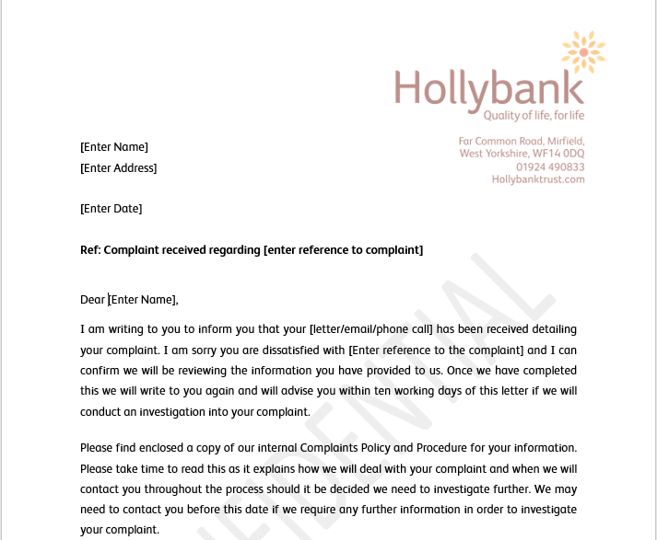
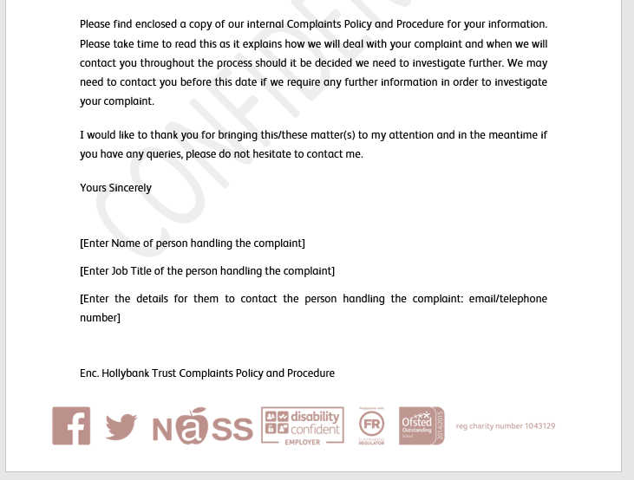
Acknowledgement of Complaint Template

Confirmation of Investigator and Process template
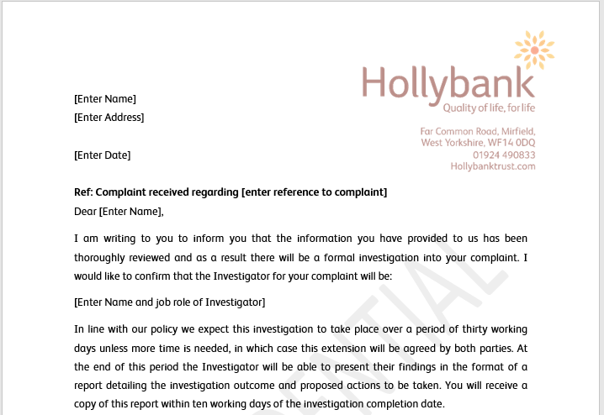
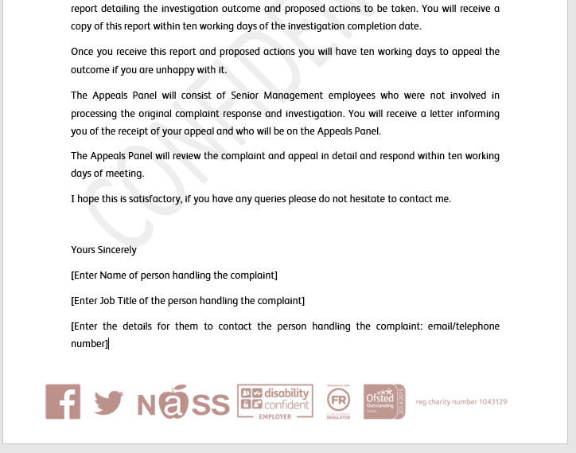

Complaint Outcome Letter Template
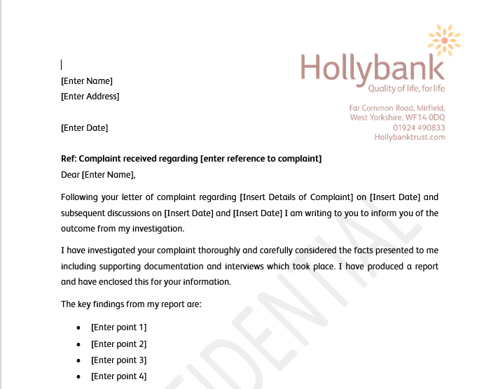
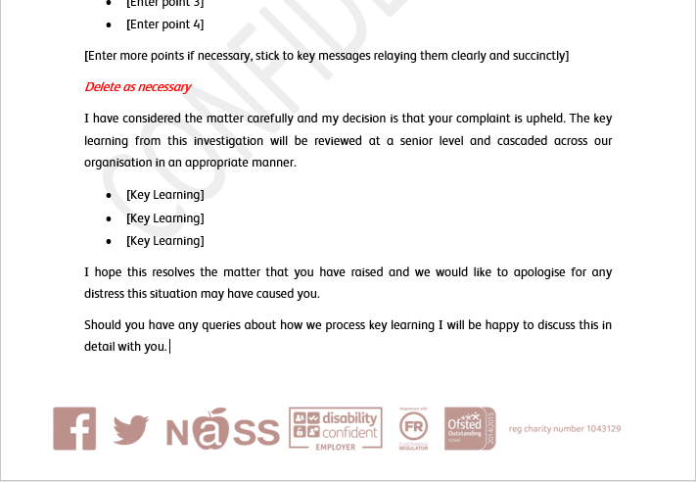

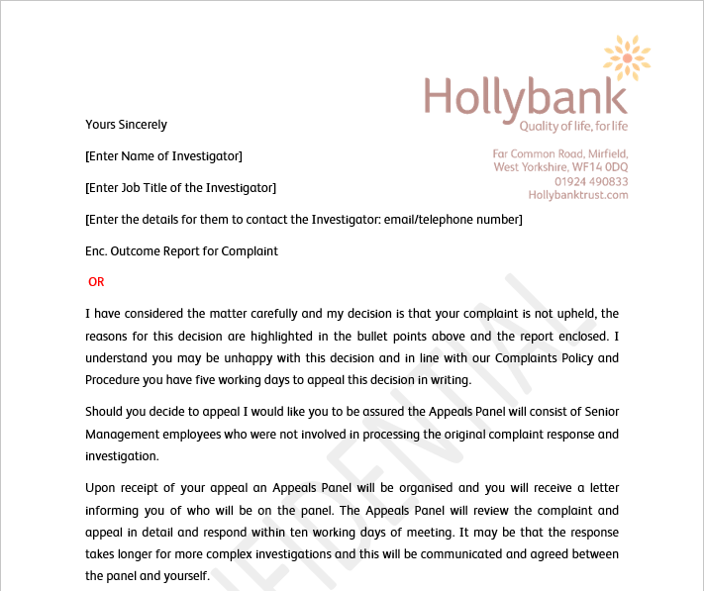
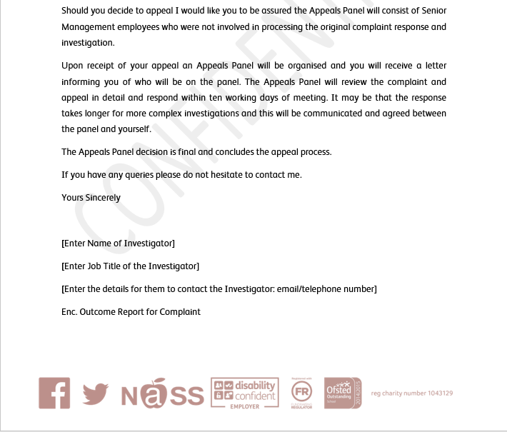

Acknowledgment of Appeal Template
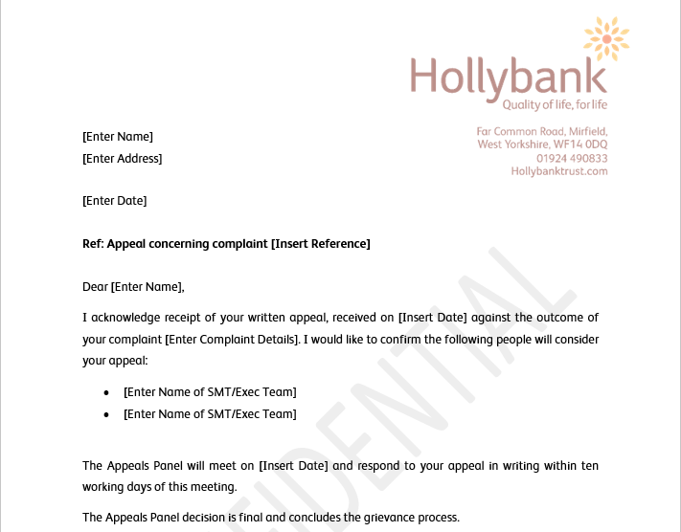
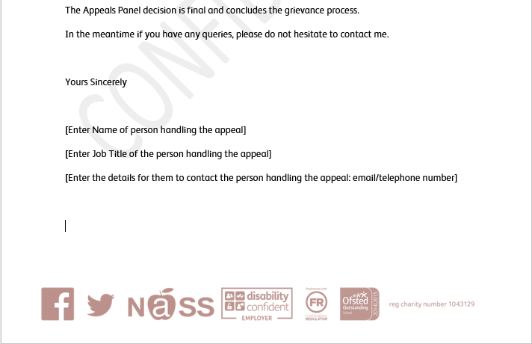

Appeal outcome Letter Template
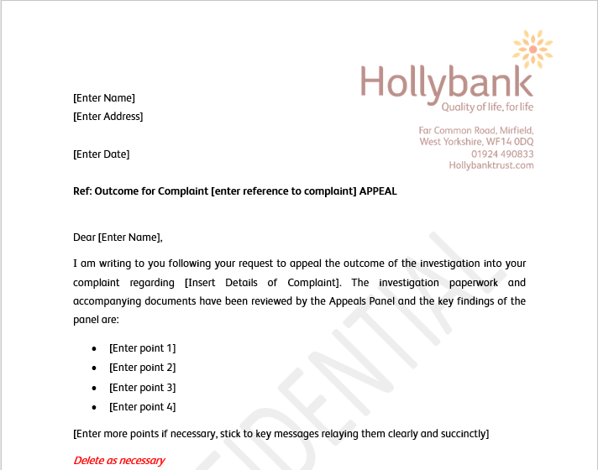
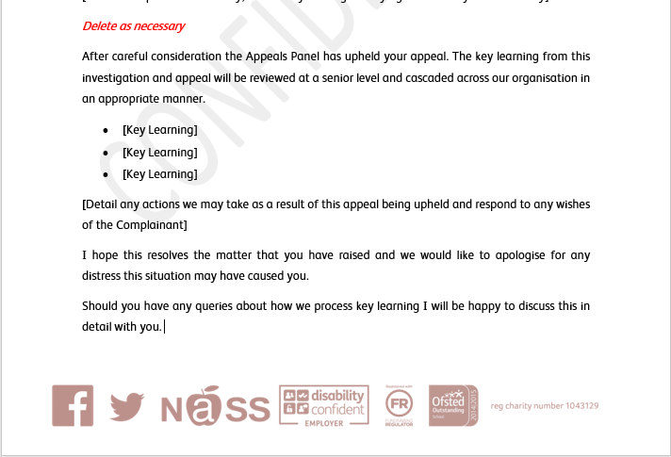

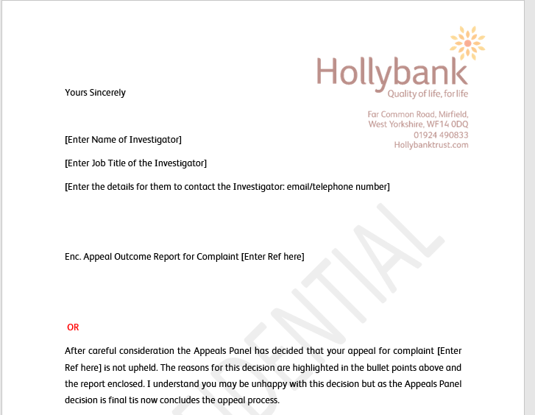
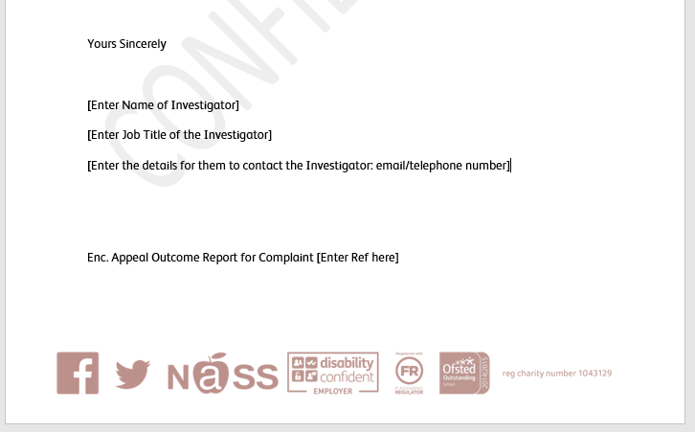

Appendix Example Letters for Children, Young People and Adults

Complaint

 | Are | 

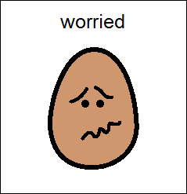 | or ? | 

Are | 
 | or
 | ?

Are
with
your support worker

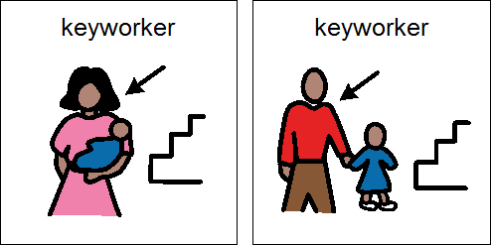
or other staff
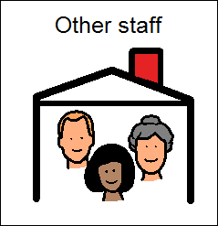 | ?

Teacher | Speech | SSA
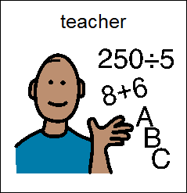 | 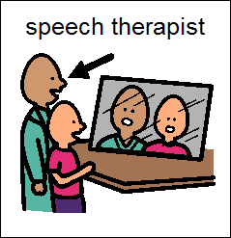 | 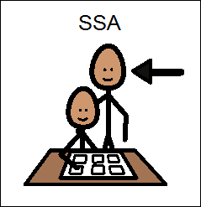
Manager | Admin | Cleaners
 | 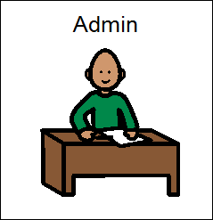 | 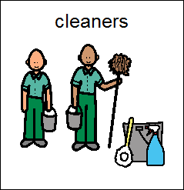
IT | Chairman | Catering Staff
 | 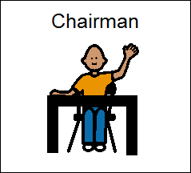 | 
Parent Governor | Nurse | Someone Else
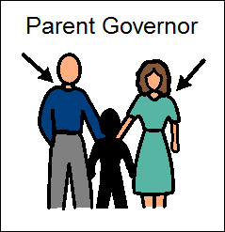 | 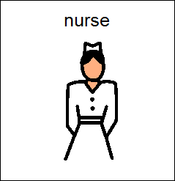 | 

Are | 
 | with
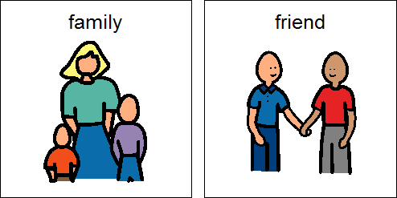 |  | ?

Are
 | with
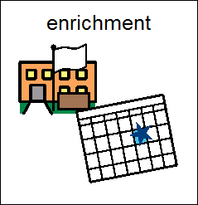 | ?

Are
 | with
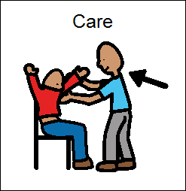 | ?

Are
 | with
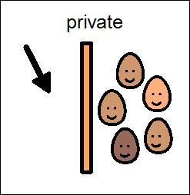 | ?

Are
 | with
 | or? | 

Are
 | with
 | ?

Are
with |  | or
 | 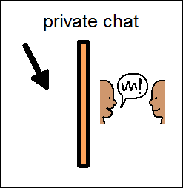 | ?

Are
 | with
 | ?

Are
 | with the
 | ?

Are
 | with
 | Or? | 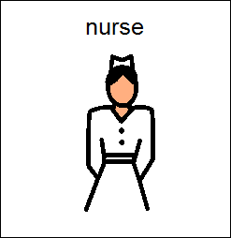

None of these?

Speak to
Your Manager | (insert photo)

 | 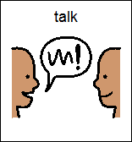
can to somebody who is not from
Hollybank | 

They are called an
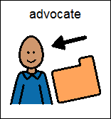 | and can
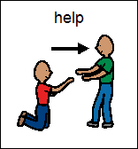 | you | 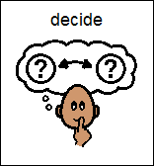
about your |  | 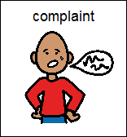

Compliment

Are
 | ?

or other staff
?

Teacher | Speech | SSA
Manager | Admin | Cleaners
IT | Chairman | Catering Staff
Parent Governor | Nurse | Someone Else

Are
 | With your
 | ?

Are
 | with
amount of | 
you have?

Are
with the
?

Are
 | with
your |  | ?

Something else?

Speak to
Your Manager | (insert photo)



Link to sample letter templates:

https://hollybankhbt.sharepoint.com/:f:/r/sites/HollybankTemportaryIntranet/policies/Additional%20Appendicies/Complaints%20Policy?csf=1&e=DE4C48

